School Incidents in NSW Public Schools - Analysis Report

1. What are the most common incident groups and categories?
Assault is the most common, followed by Indecent Assault and Possession of a Weapon.
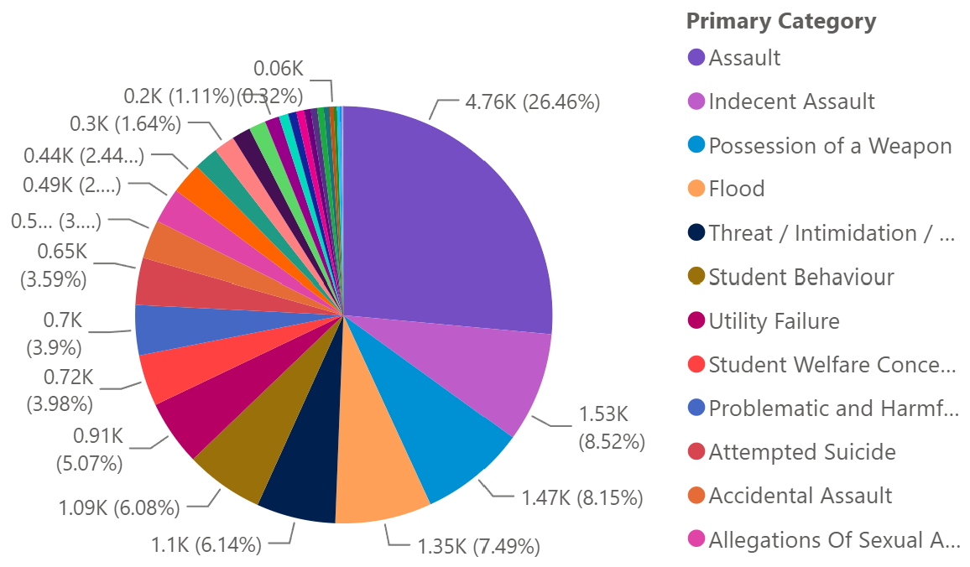

2. How has incident volume changed over time?
Upwards trend. Incidents dipped in 2020/2021 because of COVID, but sharply rose afterwards, exceeding pre-COVID (2019) years. 2023 has almost double the number of incidents in 2019.

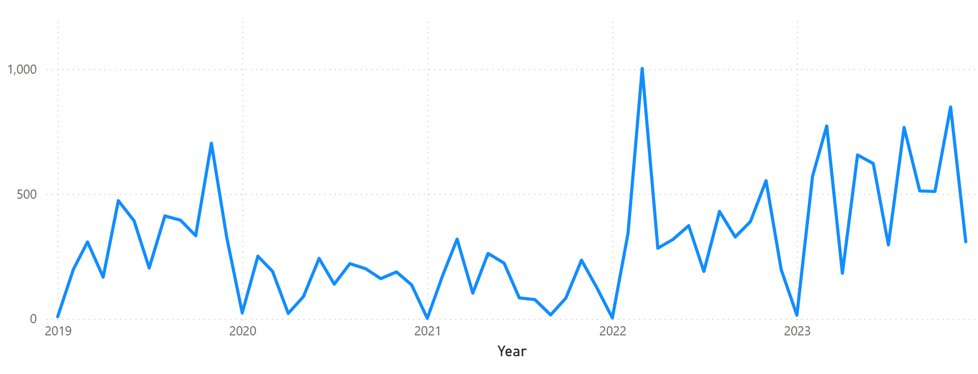
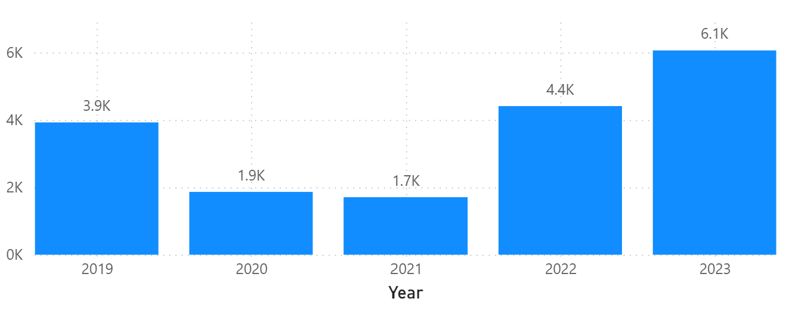

3. How does incident volume vary by school term?
No noticeable pattern. The most recent years (2022, 2023) suggest a pattern of increasing incidents in Term 1 and 4.
Incidents consistently peak during March, May, August, November.
Incidents consistently dip during January, April, July, September, December due to school holidays.
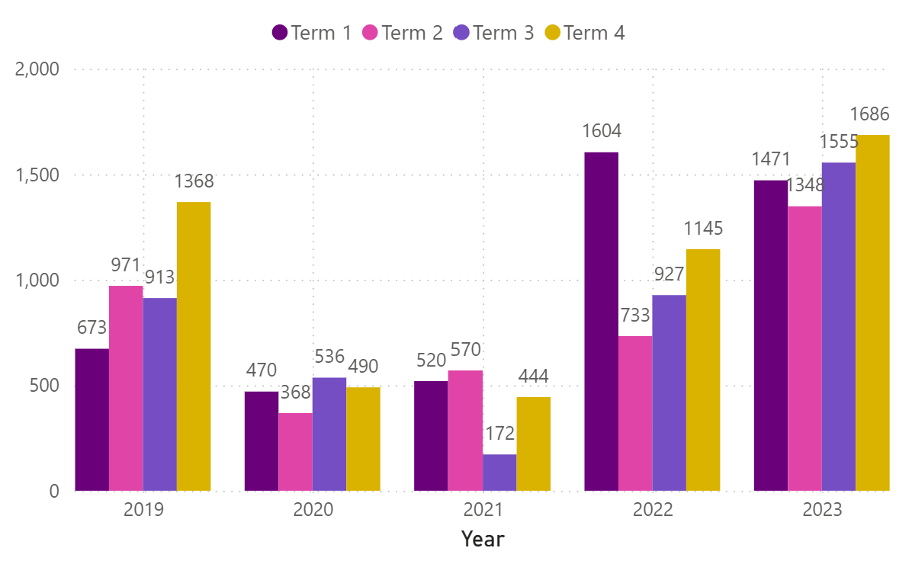
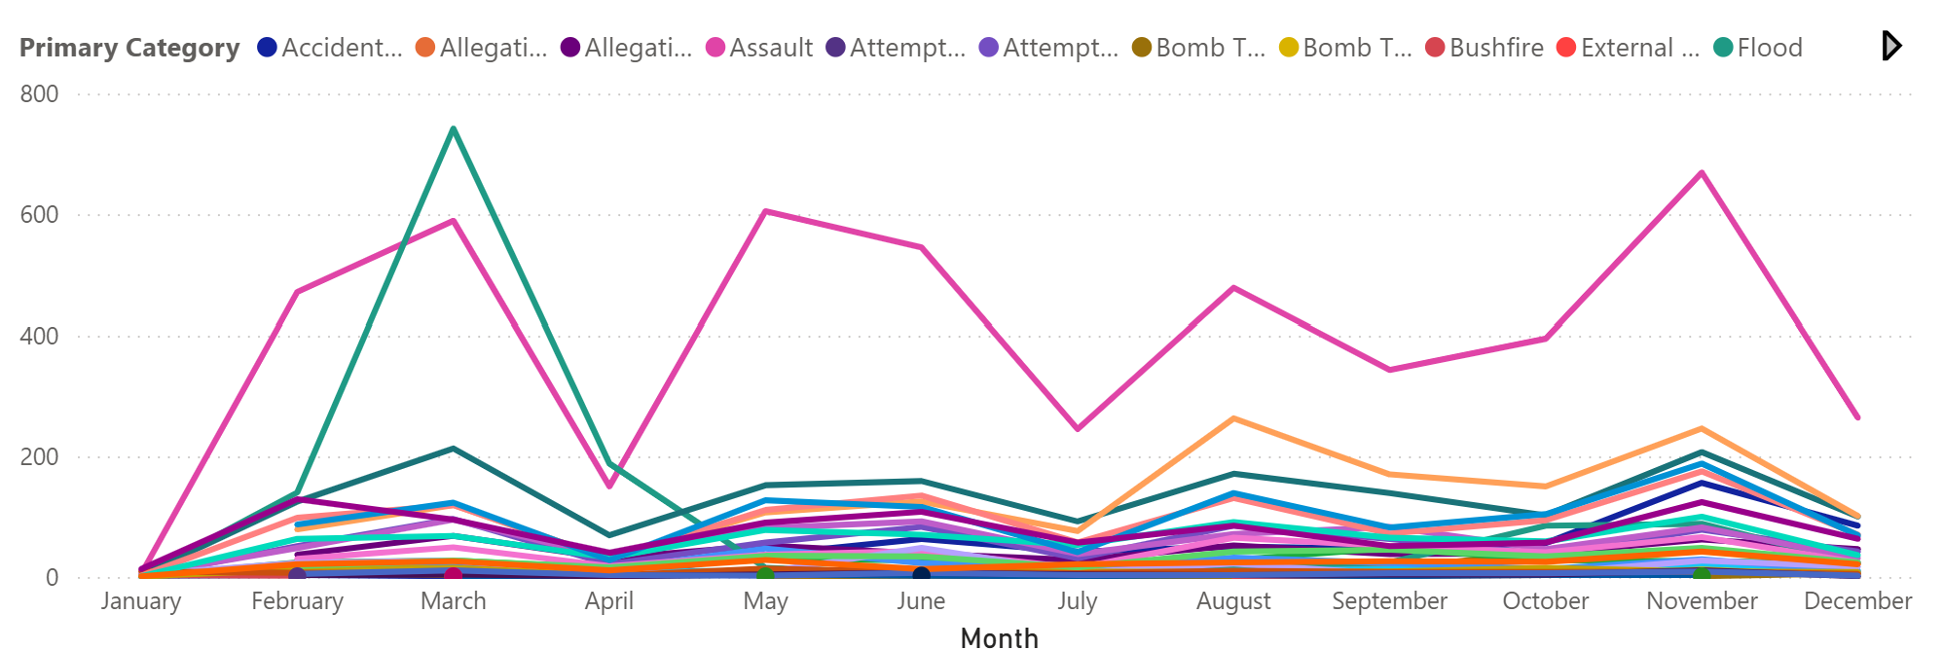

4. Where do incidents most commonly occur?
Vast majority of incidents occur at school. However, most incidents outside of school won’t be reported, so the number of incidents in ‘Off workplace grounds’ is inaccurate.

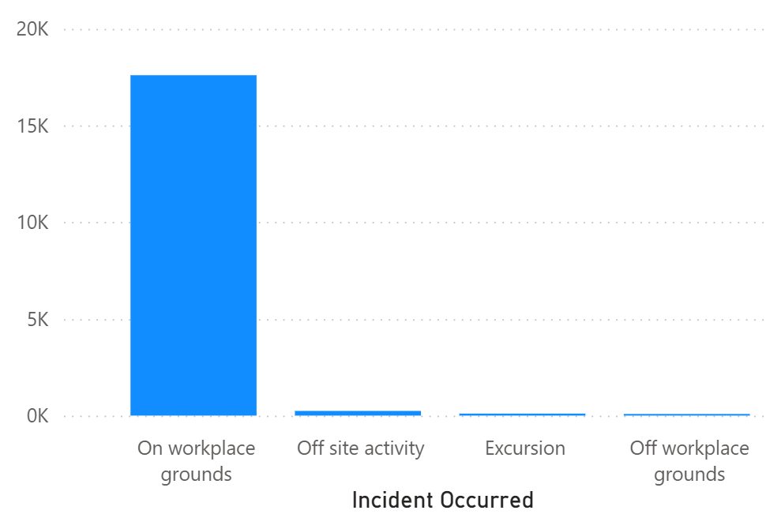

5. How does incident type vary by location/context?
Assault (PINK) and Indecent Assault (DARK GREEN) are the most common incident types. However, during excursions, Indecent Assault is more common.
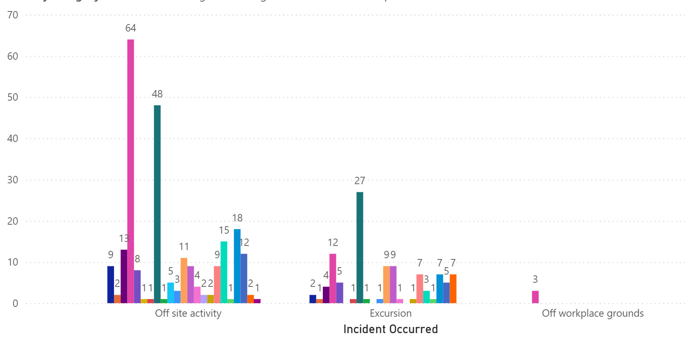

6. How does the incident profile differ between operational directorates?
Rural North and Regional South are the most vulnerable to floods.
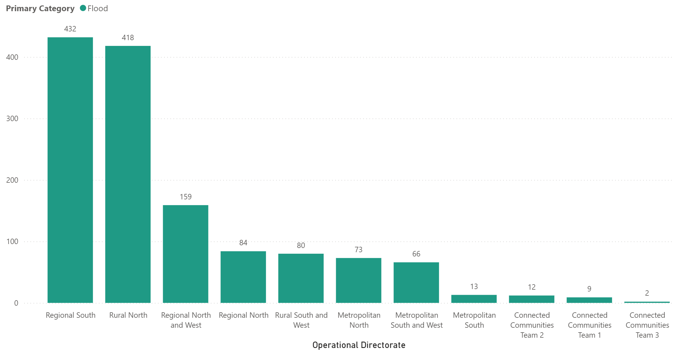Top 10 Principal Network’s by flood incidents.
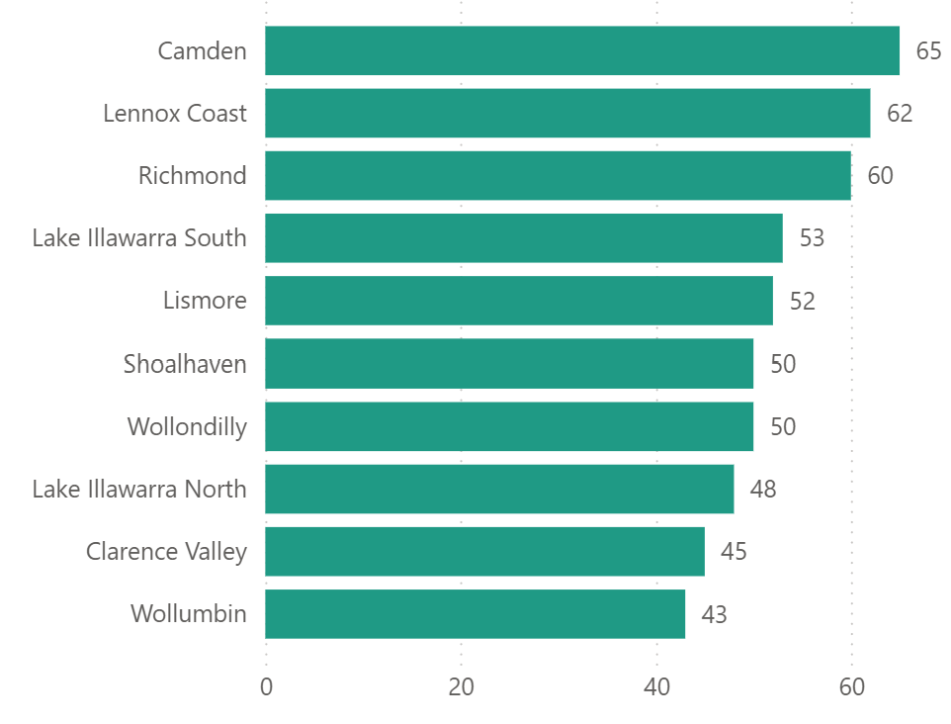

Drug use is evenly distributed.
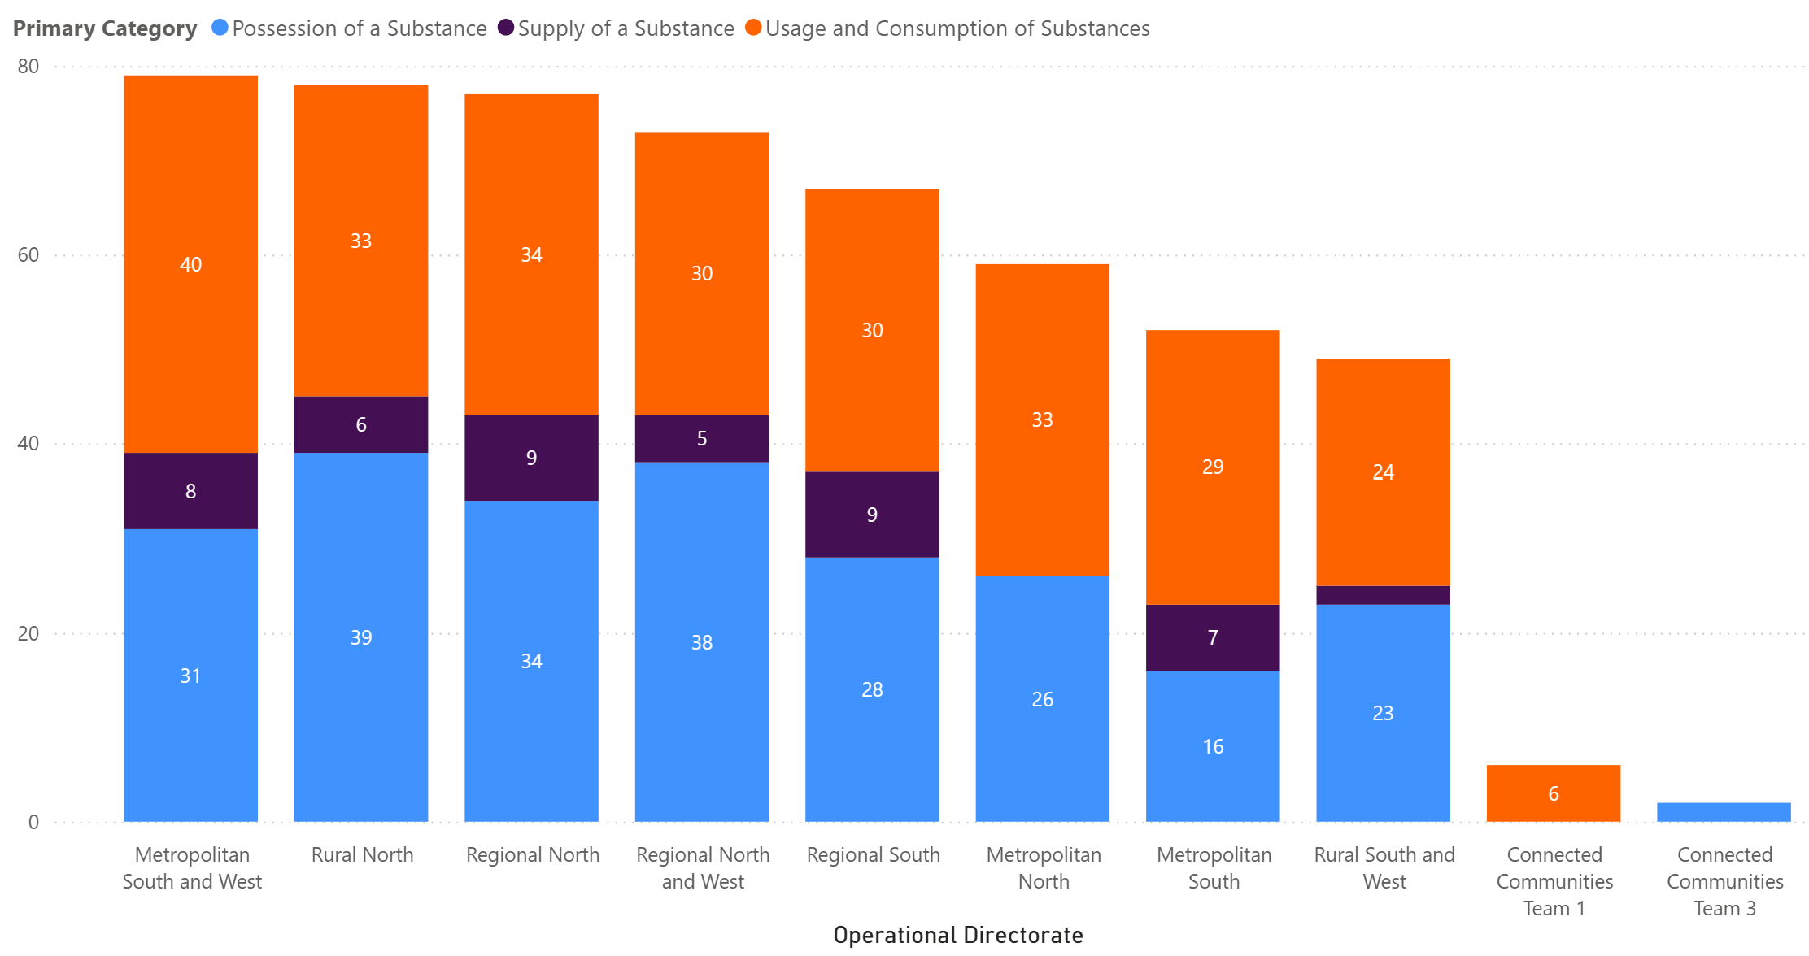
Regional North takes the lead in suicidality.
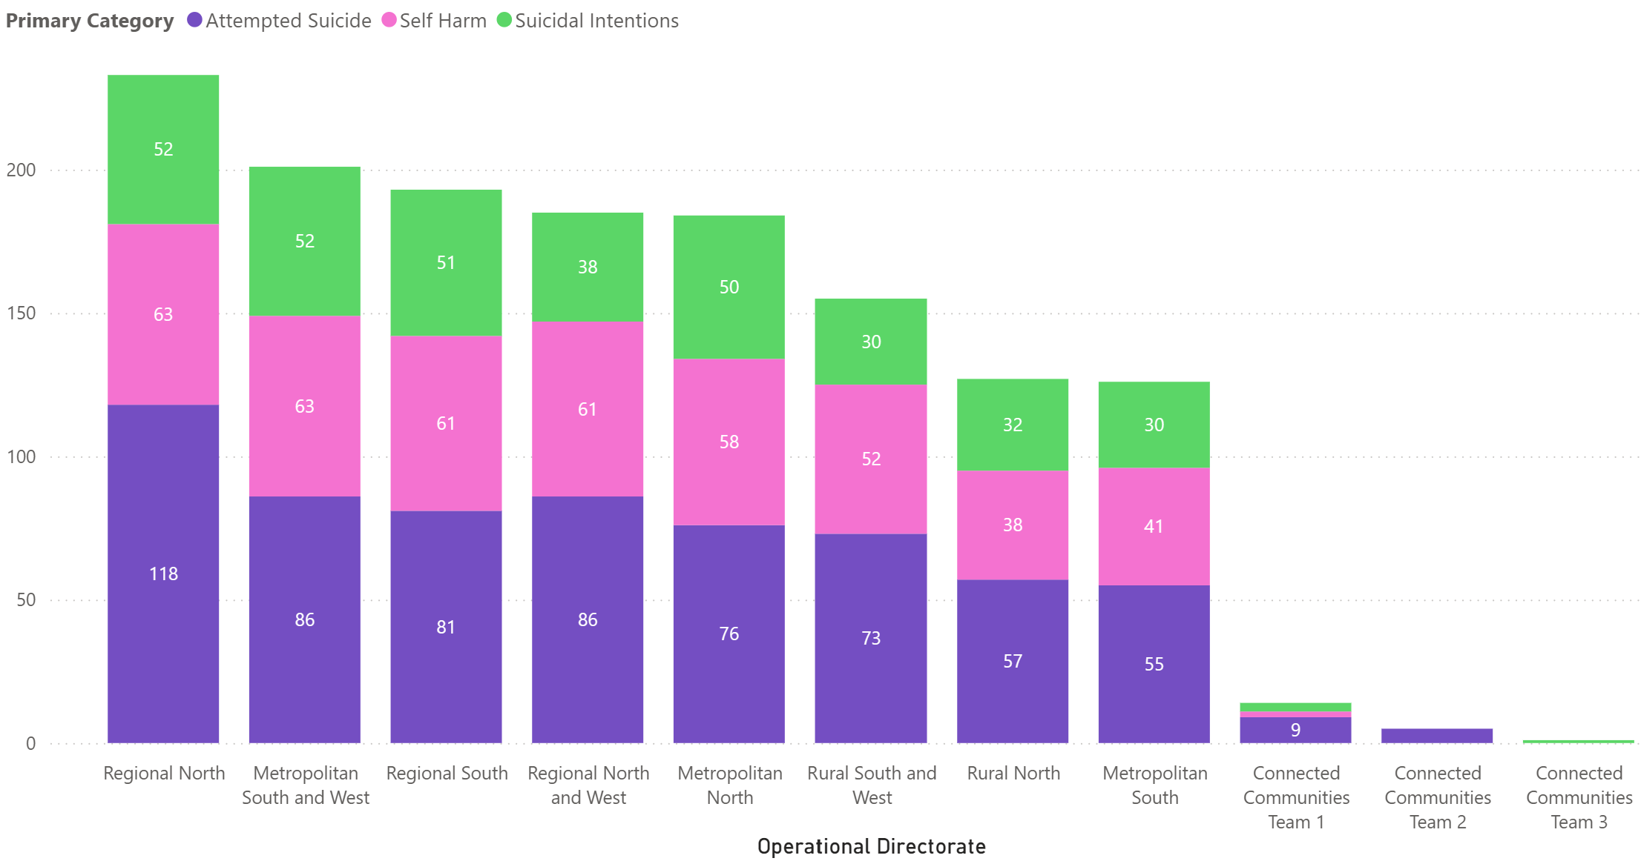

Metropolitan South and West have the highest rates of sexual incidents.
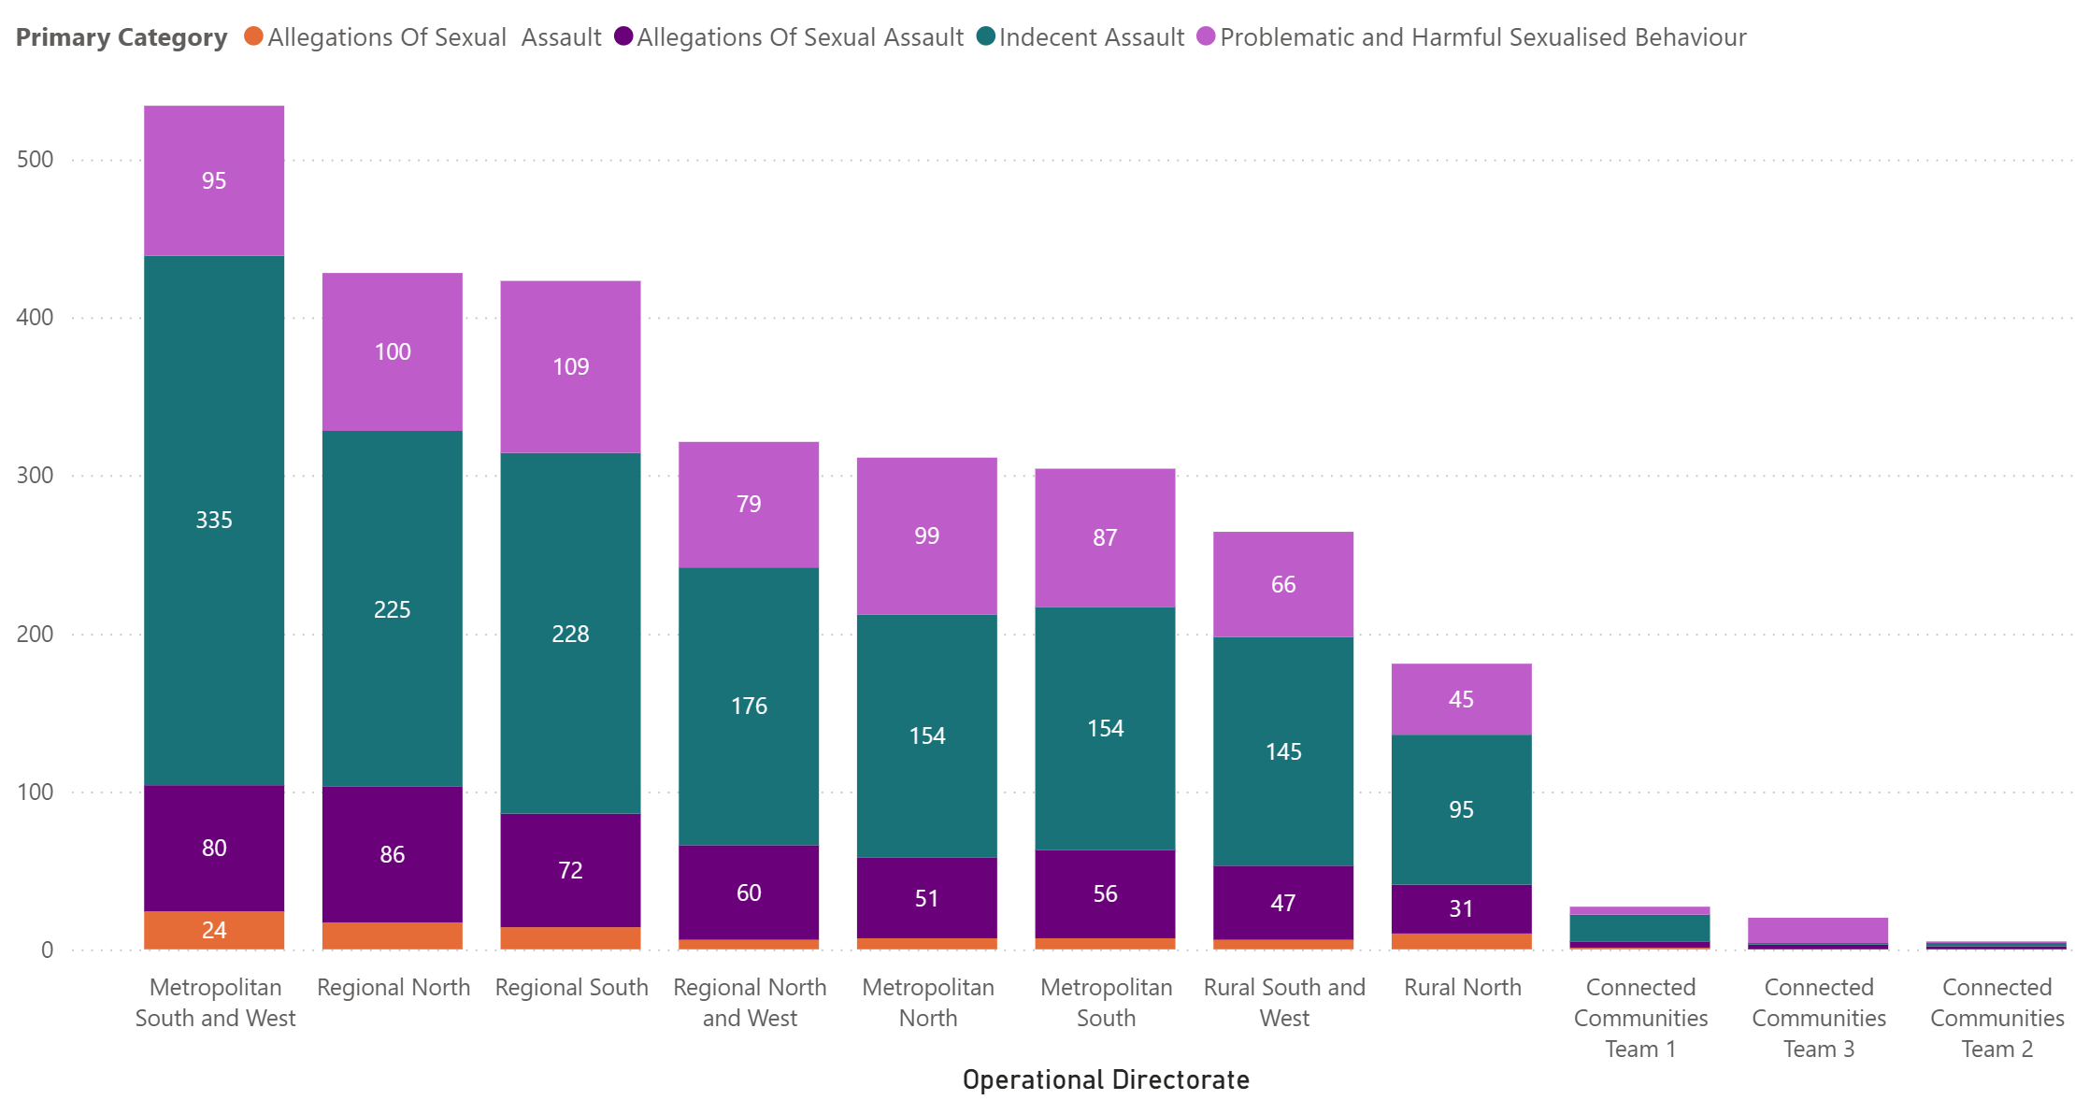
Metropolitan South and West also take the lead for the most serious incidents where police needed to be called.
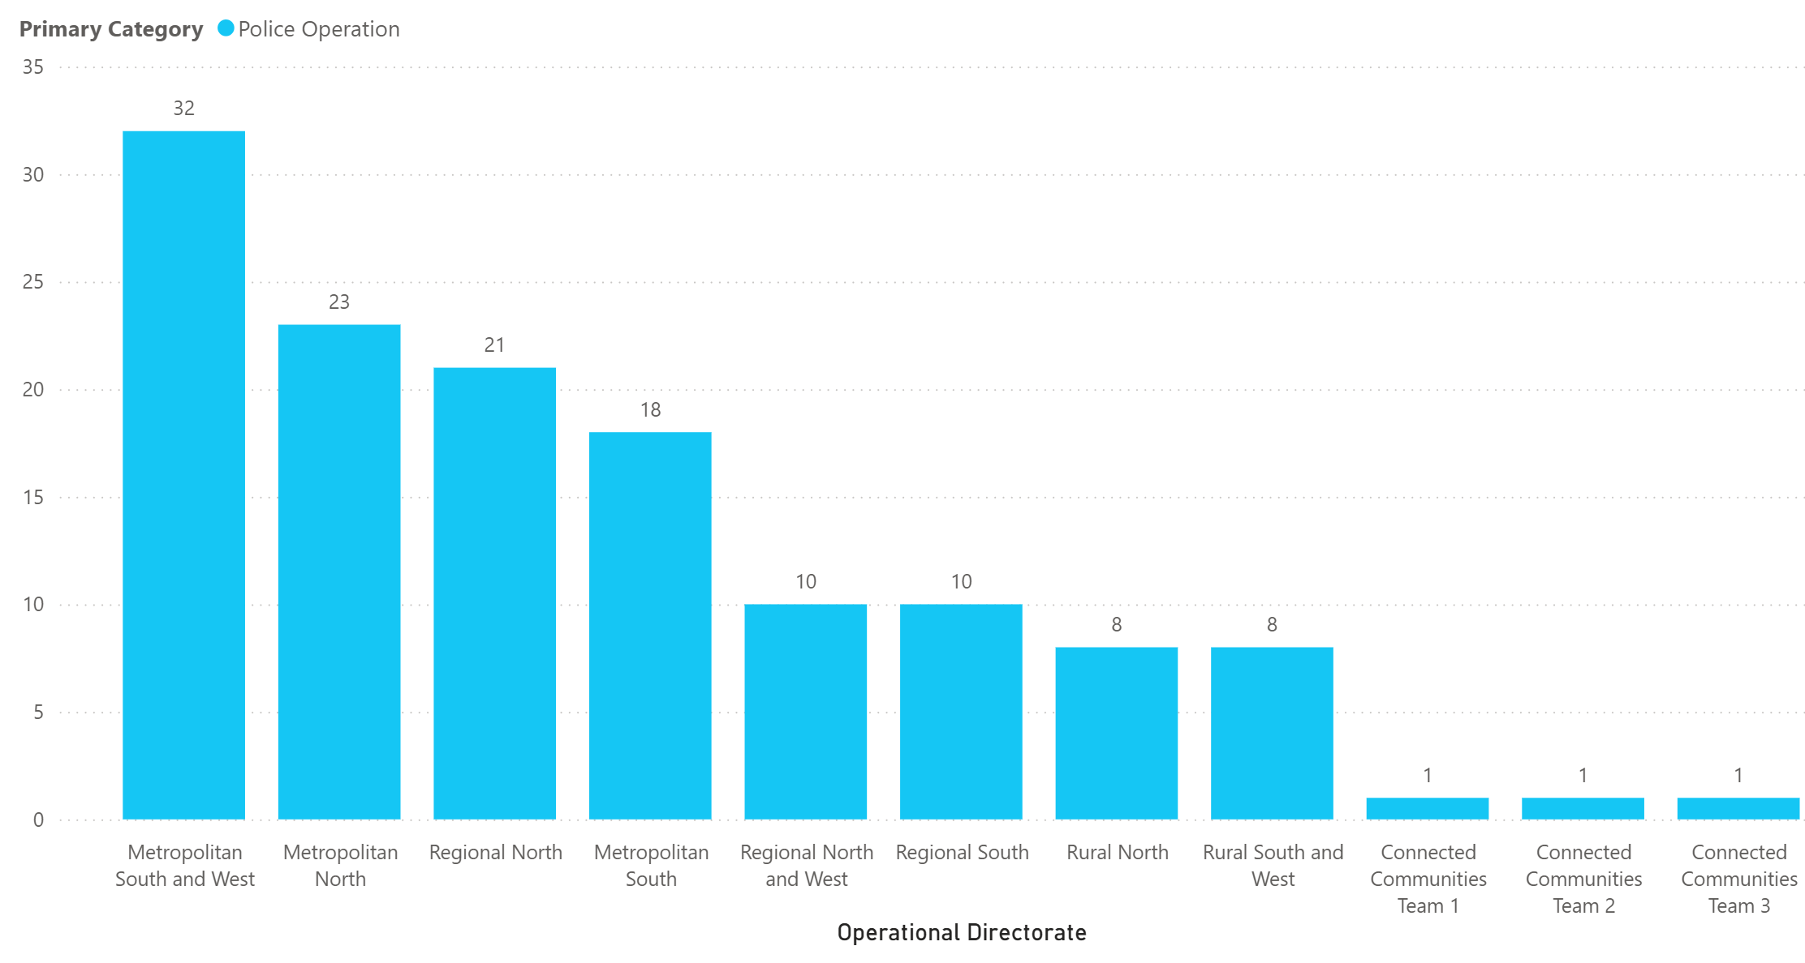

7. Has the composition of incidents changed over time?
Assault has consistently been the highest category (see question 3’s line graph).
Composition remains largely the same, with higher incident counts over time.
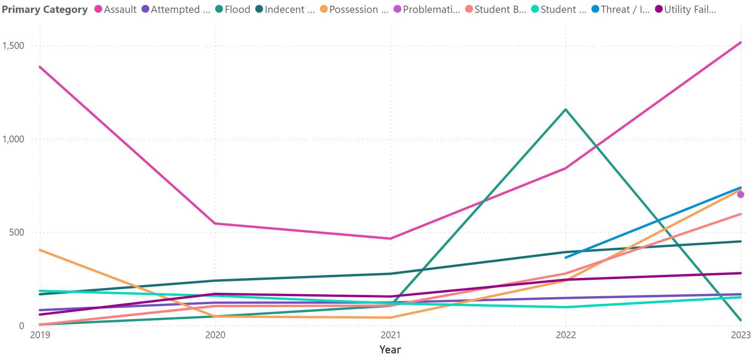
Outlier - over 1000 flood incidents in 2022.
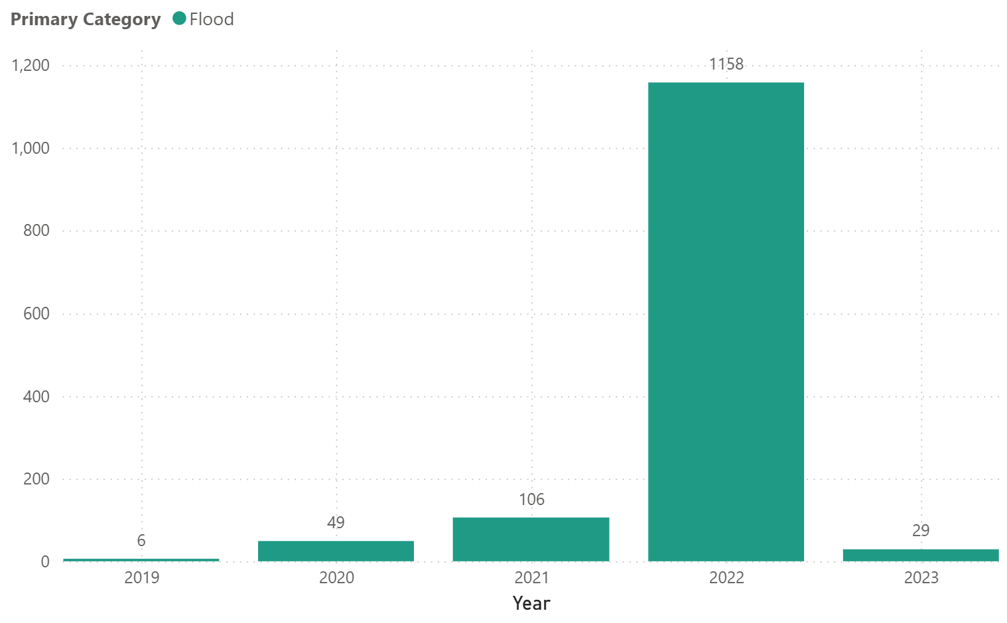

8. Top 10 Worst Principal Networks (highest incident count)
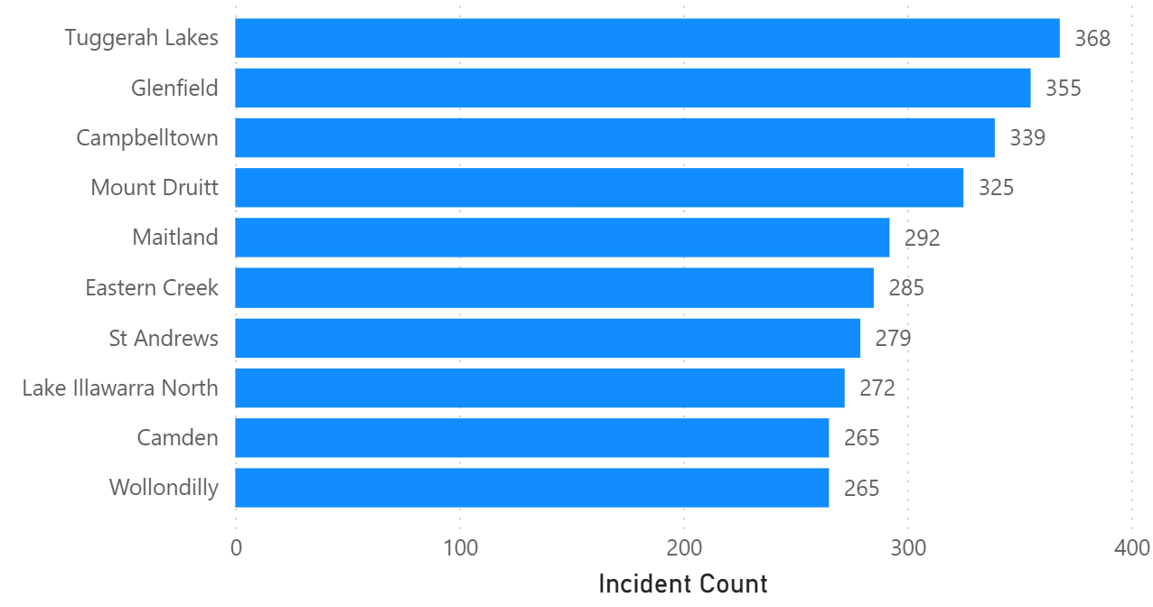

9. Top 10 Best Principal Networks (lowest incident count)
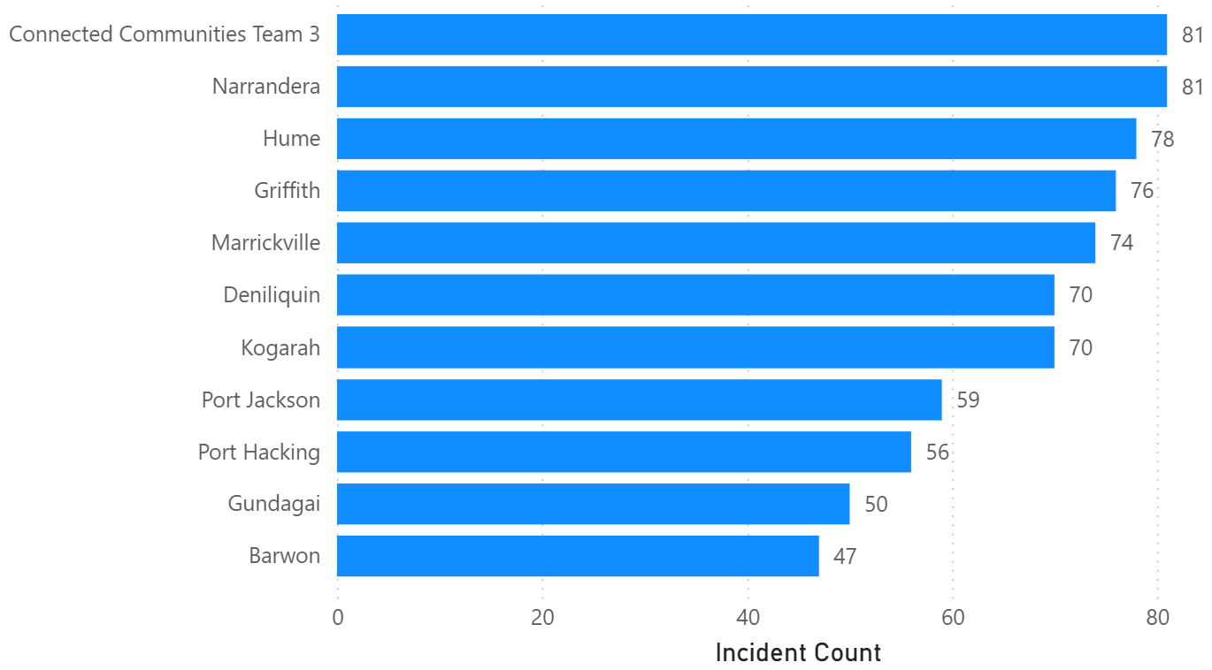

RECOMMENDATIONS:
- Increase vigilance and take extra measures when planning these activities. Indecent/sexual assault incidents were more common during off-site activities and excursions in the dataset. Schools should consider additional supervision, clear safeguarding procedures, appropriate staff-to-student ratios, and risk assessments when planning these activities.
- Increase access to student wellbeing and mental health support. The number of recorded incidents increased over the years, with a notable rise following the COVID-19 period. Schools should consider investing in accessible counselling and wellbeing services, while strengthening strategies for the early identification and intervention of students experiencing difficulties.
- Provide additional support during periods when incidents are more frequent. Incidents peak in March, May, August and November, which broadly coincide with periods of increased academic assessment and examination activity, including NAPLAN, HSC examinations and school assignments. While this pattern does not establish that academic pressure causes incidents, schools can use these periods to increase wellbeing check-ins, promote awareness of counselling and support services, provide quiet spaces, and offer additional study and academic support.

